**Lab 5**

**1. Create a page named index.php page as following.**

**Create a registration.php page for registration process of a new user as**

**following with following validations.**

**Validations:**

**User Name cannot be empty and of less than 11 characters.**

**Passwords fields cannot be empty and both must be same of length 6 to 10.**

**For gender selection only one option can be opted.**

**Home.php:**

<?php

session_start();

if(isset($_POST['submit'])){

if(isset($_POST['username']) && isset($_POST['password'])){

if($_POST['username'] == "juzar" && $_POST['password'] == "antri"){

$_SESSION['name'] = $_POST['username'];

echo "<table border='1'> ";

echo "<tr>";

echo "<td><h1>Home Page</h1></td>";

echo "<td><a href='logout.php'>Signout</a></td>";

echo "</tr>";

echo "<tr>";

echo "</tr>";

echo "<td colspan='2'>Welcome " . $_POST['username'] . "</td>";

echo "</table>";

}else{

echo "Incorrect Username/Password";

}

}

}

?>

**index.php:**

<?php

session_start();

if (!empty($_SESSION['error'])){

echo $_SESSION['error'];

}

unset($_SESSION['error']);

?>

<form action="home.php" method="POST">

<table border="1">

<tr>

<td>Username:</td>

<td><input type="text" name="username"></td>

</tr>

<tr>

<td>Password:</td>

<td><input type="Password" name="password"></td>

</tr>

<tr>

<td><input type="submit" name="submit" value="Submit Query"></td>

<td><input type="Reset" name=""></td>

</tr>

<tr>

<td colspan="2"><a href="registration.php">Newuser</a></td>

</tr>

</table>

</form>

**Logout.php:**

w<?php

session_start();

echo "Your are signed out Click <a href='index.php'>Here</a> to login again" ;

unset($_SESSION['name']);

?>

**Notification.php:**

<?php

session_start();

if(!empty($_POST['uname']) && !empty($_POST['pass'])){

if($_FILES['file']['type'] == "image/png" && $_FILES['file']['size'] <= 300000){

echo "You are registered";

echo "<table border='1 solid'>";

echo "<tr>";

echo "<td>Username:</td>";

echo "<td>" . $_POST['uname'] . "</td>";

echo "<td rowspan=7>";

$location='D:/Workspace/DDU SEM 4 PROGRAMS/DM/Lab 5/Task 1/';

if(move_uploaded_file($_FILES['file']['tmp_name'],$location.$_FILES['file']['name'])){

echo '<img src ="'.$_FILES['file']['name'].'" width=100px height=100px/>';

}

echo "</td>";

echo "</tr>";

echo "<tr>";

echo "<td>Gender:</td>";

echo "<td>" . $_POST['gen'] . "</td>";

echo "</tr>";

echo "<tr>";

echo "<td>Date of birth[YYYY-MM-DD]:</td>";

echo "<td>" . $_POST['date'] . "</td>";

echo "</tr>";

echo "<tr>";

$temp = $_POST['in'];

if($temp[0]){

echo "<td>Training:</td>";

echo "<td>" . $temp[0] . "</td>";

echo "</tr>";

}else{

echo "<td>Training:</td>";

echo "<td>" . 'Not interested' . "</td>";

echo "</tr>";

}

if($temp[1]){

echo "<td>Placement:</td>";

echo "<td>" . $temp[1] . "</td>";

echo "</tr>";

}else{

echo "<td>Placement:</td>";

echo "<td>" . 'Not interested' . "</td>";

echo "</tr>";

}

echo "<td>Achievements:</td>";

echo "<td>" . $_POST['achievements'] . "</td>";

echo "</tr>";

echo "<tr>";

echo "<td colspan=2><a href='../Task 1/''>Return Home</a></td>";

echo "</tr>";

echo "</table>";

}else{

$_SESSION['error'] = "Either file type is not appropriate or is greater than 300kb";

header("Location: index.php");

die();

}

}else {

echo "Username or password empty";

}

?>

**Registration.php:**

<form method="POST" action="notification.php" name="myForm" enctype="multipart/form-data" required>

<table border="1">

<tr>

<td colspan="3">*Required field</td>

</tr>

<tr>

<td colspan="1">*Username:</td>

<td colspan="2"><input type="text" maxlength="11" minlength="1" name="uname"></td>

</tr>

<tr>

<td colspan="1">*Email Address:</td>

<td colspan="2"><input type="text" name="email"></td>

</tr>

<tr>

<td colspan="1">*Password:</td>

<td colspan="2"><input type="Password" name="pass" minlength="6" maxlength="10"></td>

</tr>

<tr>

<td colspan="1">*Confirm Password:</td>

<td colspan="2"><input type="Password" name="" minlength="6" maxlength="10"></td>

</tr>

<tr>

<td colspan="1">*Gender:</td>

<td colspan="2"><input type="radio" name="gen" value="Female">Female &nbsp<input type="radio" value="Male" name="gen">Male</td>

</tr>

<tr>

<td colspan="1">*Birth date:</td>

<td colspan="2"><input type="date" name="date"></td>

</tr>

<tr>

<td colspan="1">*Interested in:</td>

<td colspan="2"><input type="checkbox" name="in[]" value="Interested">Training &nbsp<input type="checkbox" name="in[]" value="Interested">Placement</td>

</tr>

<tr>

<td colspan="3">Achievements:</td>

</tr>

<tr>

<td colspan="3"><textarea name="achievements" rows="10" cols="40"></textarea></td>

</tr>

<tr>

<td colspan="1">*Select your file:</td>

<td colspan="2"><input type="file" name="file"></td>

</tr>

<tr>

<td colspan="1"><input type="submit" name="submit"></td>

<td colspan="1"><input type="reset" name=""></td>

<td colspan="1"><a href="../Task 1/">Home</a></td>

</tr>

</table>

</form>

**Output:**

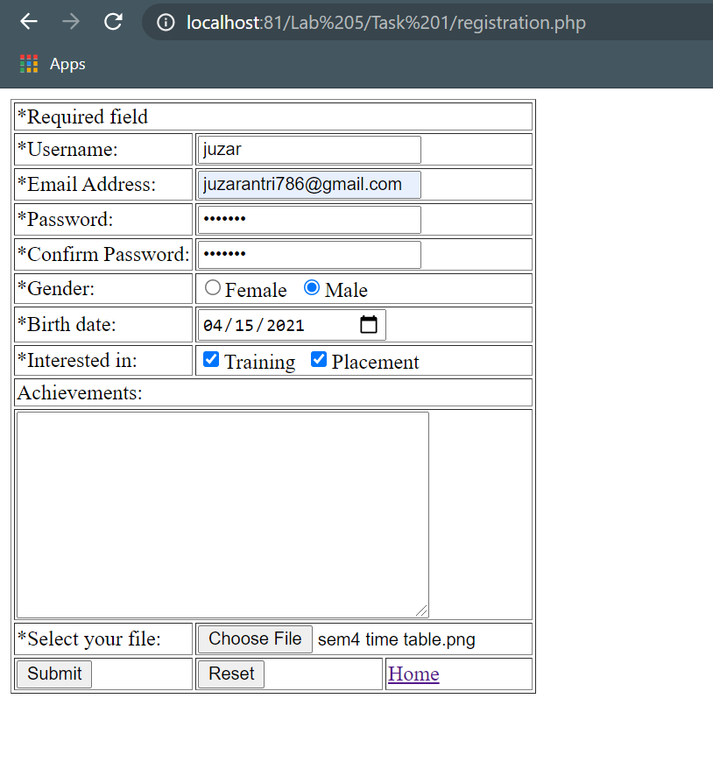

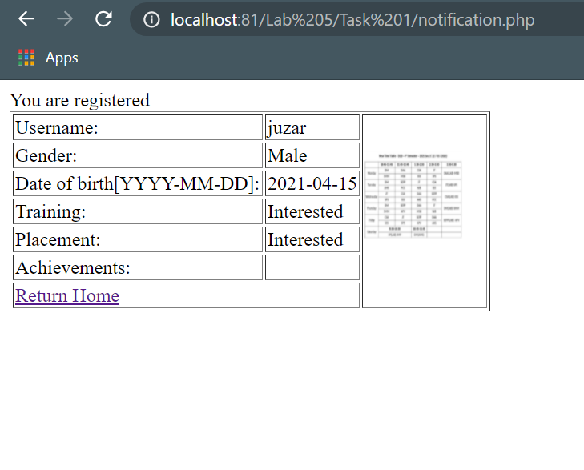

**2. Write a php code that open a file and read the first ten characters from it.**

**Code:**

<?php

$file = fopen('temp.txt', 'r');

echo fread($file, 10);

fclose($file)

?>

**Output:**

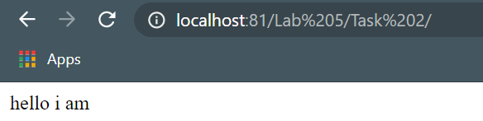

**3. Write a php code that open a file and read first character at current position.**

**Code:**

<?php

$file = fopen('temp.txt', 'r');

echo fread($file,ftell($file)+1);

fclose($file)

?>

**Output:**

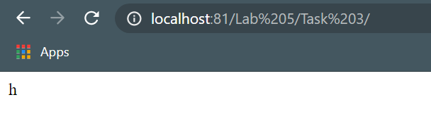

**4. Write a php code that shows the difference between fgets() and fgetss().**

**Code:**

<?php

$file = fopen('temp.txt', 'r');

echo "fgets function does treats the html tag as html elements<br>";

echo fgets($file);

echo "<br>fgetss function does not treats the html tag as html elements and simply ignores it<br>";

echo "<b>Its error bcz fgetss is depriicated</b>";

fseek($file, 0);

echo fgetss($file);

fclose($file);

?>

**Output:**

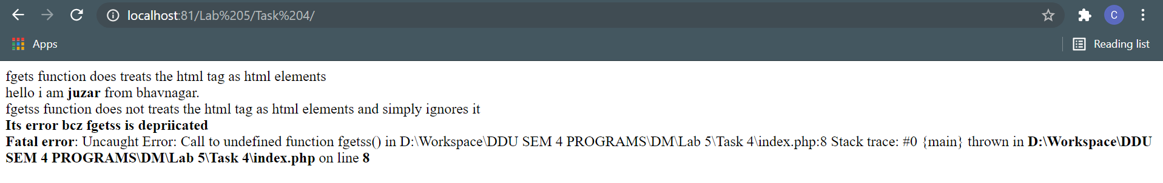

**5. Write a php code that checks whether a file exist or not and if does exist than it renames it.**

**Code:**

<?php

if(file_exists('temp.txt')){

rename('temp.txt','new.txt');

echo "file renamed successfully";

}else {

echo "File does not exists";

}

?>

**Output:**

